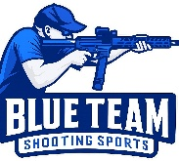
Blue Team Shooting Sports A.S.S.S. January 24th 2026
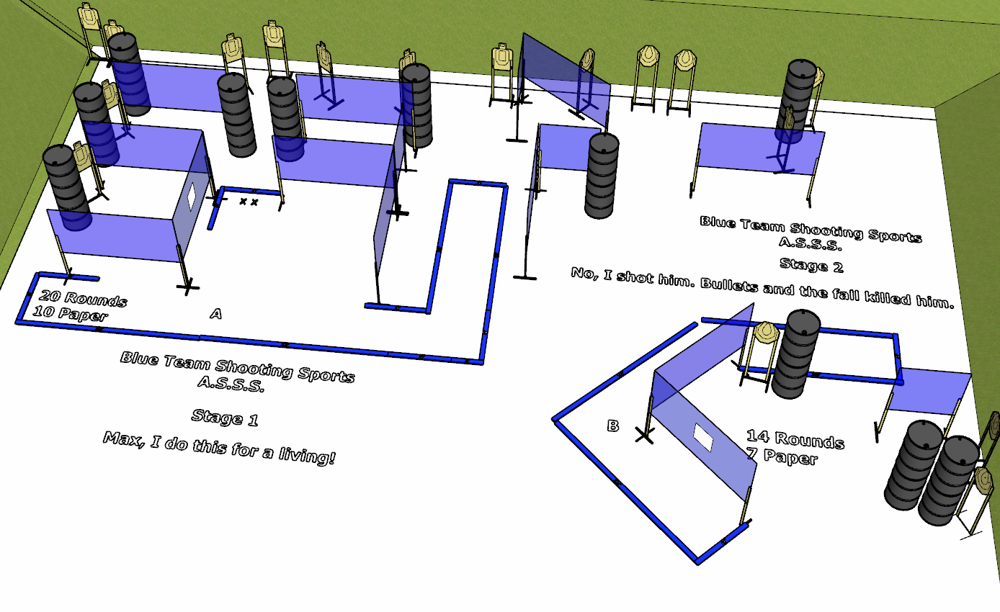

Written Stage Briefings:

Stage 1 - Max, I do this for a living! is a 20 round, 100 point, Comstock course. There are 10 cardboard targets. The best 2 hits per cardboard target will be scored.
Start position Both feet on the Shooting Sports Innovations Xs.
Handgun: Loaded and holstered, wrists below belt
PCC: Loaded, stock touching belt
On the audible start signal, engage targets from within the shooting area A.

Stage 2 - No, I shot him. Bullets and the fall killed him. is a 14 round, 70 point, Comstock course. There are 7 cardboard targets. The best 2 hits per cardboard target will be scored.
Start position Anywhere
Handgun: Loaded and holstered, wrists below belt
PCC: Loaded, stock touching belt
On the audible start signal, engage targets from within the shooting area B.

Stage 6 - Well, that was brilliant... is a 34 round, 170 point, Comstock course. There are 17 cardboard targets. The best 2 hits per cardboard target will be scored.
Start position Anywhere
Handgun: Loaded and holstered, wrists below belt
PCC: Loaded, stock touching belt
On the audible start signal, engage targets from within the shooting areas.

